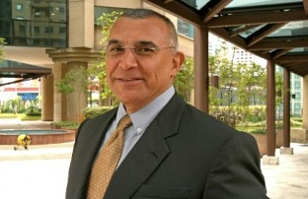
BIZ & IT COACH CV

NAME: Alejandro Urias Mora
OFFICE: Cañón Silencio 205 Lomas Valle Dorado, Tlalnepantla, Edo. Mex. C.P. 54020
PHONE: 55 8421 4366 Skype, 55 5400 5125 cel.
Email: aurias@prodigy.net.mx, capiaurias@gmail.com
LANGUAGES: Spanish: Mother language.
English: Understands 100%, talk fluently.

Main projects & Skills:
- Enterprise Architecture
- Lean Enterprise/Business Transformation
- BPM – Business Process Management
- Performance Management, Activity Monitoring
- I/T Governance, Portfolio Management
- PMO – Project Management Office
- I/T Consulting (BSM, BCP/BIA, etc.)
- KM/BI – Business Knowledge/Intelligence
- ERP, CRM, GRP, CRM (SAP Health Check)
- On Demand Services, IT/ BP Outsourcing.
- Business & IT Audit Solutions (ITIL,COBIT,CMMI)

Main achievements:
2011- BCP Cedis OXXO actual
2011- Security strategy company wide Liverpool
2010- SAP Implementation UR Mty

Professional History:
2006 – Actual Biz & IT Coach, freelance consultant & project mgr
2005 – Jan 2006 Sybase Mexico Country Manager
1993 – 2004 General Managers of CAPI S.C. and IT consulting firm.
Main projects & Skills:
BSM, ITSM-ITIL
SAP planning and implementation
IT Architecture planning and implementation
SLM planning and implementation
IT Governance structure (organization)
BPR, SCM, BPM

