CURRICULUM VITAE
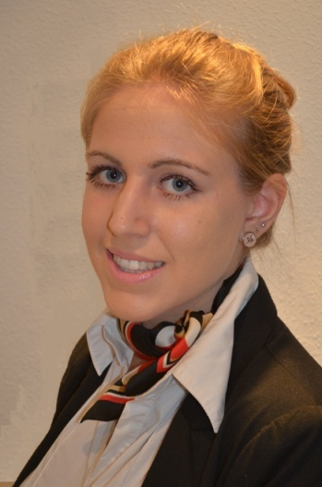
PERSONAL INFORMATION

Apellidos: Albusac Muñoz
Nombre: Belén
Dirección: C/ San Joaquín, Nº16A, 4ºD; 18013 Granada, Andalucía, España
Teléfono móvil: +34 619-794-444
E-mail: belenam@correo.ugr.es
Nacionalidad: Española
Sexo: Femenino
Fecha de caducidad del pasaporte: 02/06/2020
Fecha de nacimiento: 08/11/1994
Edad: 23
Idiomas: Español, inglés, francés, ruso, italiano, alemán
FORMACIÓN PROFESIONAL

*Octubre 2017/ en curso: Máster en Profesorado de Educación Secundaria Obligatoria y Bachillerato, Formación Profesional y Enseñanza de Idiomas. Universidad de Granada.

*2012/2016 – Grado en Traducción e Interpretación. Facultad de Traducción e Interpretación. Universidad de Granada

*Noviembre 2013/ marzo 2014 – Curso de Entrenamiento Inicial para Tripulante de Cabina de Pasajeros. Academia FORMAS formación, Granada

EXPERIENCIA LABORAL

- Septiembre 2016- septiembre 2017: Azafata de vuelo. Ryanair airlines.
- Enero 2016-mayo 2016: Oficina de Turismo. Ayuntamiento de Granada
- Junio- agosto 2015: Au-Pair en Lake Elsinore (California, Estados Unidos)
- Junio 2012: Monitora voluntaria de actividades extraescolares. Colegio San Isicio (Cazorla, Jaén)
- Junio 2011: Monitora voluntaria de maratones amistosas de secundaria. Instituto Castillo de la Yedra (Cazorla, Jaén)

COMPETENCIAS LINGÜÍSTICAS
- Junio 2016: Certificado nivel pre-intermedio de francés (B1). Escuela de Idiomas.
- Noviembre 2016: Cambridge Certificate in Advanced English (C1)
- Abril 2013: Curso de Lenguaje No Verbal y Comunicación Estratégica

IDIOMAS

- Español: Lengua materna

- Inglés: Nivel avanzado

- Francés: Nivel intermedio

- Ruso: Nivel básico-intermedio

- Italiano: Nivel básico

- Alemán: Nivel básico

COMPETENCIAS Y HABILIDADES SOCIALES

- Julio 2012: Estancia en Irlanda (Bray) durante un mes para perfeccionar el idioma.
- Agosto 2011: Estancia en Francia (Montpellier) durante tres semanas para perfeccionar el idioma.

CARNET DE CONDUCIR
Clase B

TO WHOM IT MAY CONCERN

I was excited to know about the vacancies offered by I.E.S Foundation to work as a Spanish assistantship in the USA, so I was looking forward to enclosing my CV for your consideration.

As you will see from my CV, two years ago I worked in a tourism office for around five months, helping tourists to get their bearings and translating several tourist brochures for the city council. Simultaneously, I managed to finish my studies (Bachelor’s Degree in Translation and Interpreting) at the University of Granada. Last year I worked as a cabin crew for Ryanair airlines for twelve months (6 months stay in Bulgaria and 6 months stay in Germany), dealing with a vast variety of nationalities on a regular basis. Both jobs granted me the opportunity to improve my level of English, French and Russian as to accuracy and fluency, as well as to communicate with people coming from all over the world, well-attached to a certain culture, traditions and customs. In September 2017 I decided to continue studying and enrolled in a Master’s Degree in Languages Teacher Training at the University of Granada, since teaching languages constitutes one of my life-long passions. Although I do not count on any remarkable experience in teaching yet, three years ago I went to the USA and worked as an au-pair for a one-and-a-half-year-old girl for the whole summer time period. Despite not being much familiarized with methods by that time, I managed to teach her some English words and animal sounds through games, reading and repetition. The reason why I applied for this assistantship position is because I would really like to be living abroad again, to acquire some teaching experience and learn from different and riveting teaching methods and techniques teachers and learners use in the USA. As far as I am aware, being a professor does not imply only teaching students certain contents from a particular area, but also giving them some life lessons that do not appear in any course book (such as coeducation, interculturalism, environment care, so on and so forth). Besides, Spanish assistantships have to take into account some general facts: USA is a melting pot, and they might bump into students belonging to different cultures and countries than theirs, their cognitive thinking might also be different and, when it comes to teach new words, for example, it would not be enough to write down a list of words on the blackboard. When it comes to learn a new word, it is crucial to know the meaning of it, the forms of it, how to use it in context and the words patterns usually appearing next to it.

In a nutshell, I will be keen to discuss my application further and would love to attend one of your personal interviews. Thank you beforehand for this second-to-none opportunity.

Kind regards,

Belén

