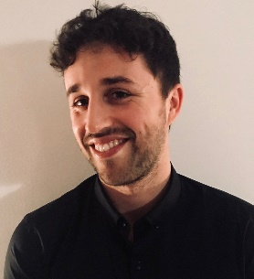
Robert Brooksbank
Adress: C/ Jacint Verdaguer Nº19
L’Ametlla de Mar
Tarragona, España
43860
Telephone Number: 0034660992456
Email: rbrooksbank.tr@gmail.com
Date of Birth: 12/06/1991

Skills
- Great ability to work under pressure.  - Willing to adapt to any job.  - High level using Microsoft Office. | - I do everything to the best of my abilities.  - Very organized and a perfectionist.  - Take pride in my work.

Experience
2007 4 months working as a Waiter at Restaurant Pescador.
2009 7 Months working as Waiter and Receptionist at L’Hotel L’Ametlla de Mar ****.
2011 6 months working as an intern in the Marketing department at BIC International Tarragona.
- 8 Months working as assistant for David William Greaves at Dunhill.
2013-2017 Football trainer for under16’s in l’Ametlla de Mar Football club.
2015-2018 Working as an English Teacher at Acadèmia Saraï, Cambridge Academy.
2016-2018 3 years doing freelance translations and Interpretations.

Education
2008: Graduated in Obligatory Secondary Education
2010: Graduated in Social Baccalaureate
2012: Degree in commerce and Marketing at I.E.S Vidal I Barraquer
2013: Graduated in health and Safety.
2017: Degree in Translation English-Spanish, Spanish-English at International House Bcn.

. Languages

English: Native
Catalan: Native
Spanish: Native

Activities
I have been translating from a very young age for my family and friends, I moved to Catalonia, Spain when I was 10 years old and soon learnt the language as if I was a native. I have been enjoying doing translations for the past 3 years but I feel it is time to take it up on a permanent basis, it is my passion I feel that I am more than accomplished to take on any kind of work.
I have flexible hours at my current teaching job and plenty of energy to get to work!
2

