LLAVE NUÑEZ, Andrea Giselle – FREELANCE TRANSLATOR
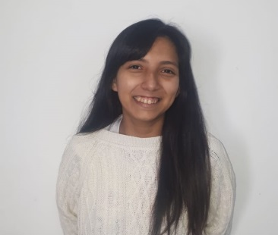 | CONTACT DETAILS  ID 37.279.041 Argentinian  Born in 03/09/1993 – 25 years old  Buenos Aires, Uriburu 381 4to H, and Av Corrientes  +54 011 2119545, +54 11 15 5037 5508 (mobile phone)  andrea.llave09@gmail.com  Language combination  ENGLISH>SPANISH  SPANISH>ENGLISH  Native Spanish Speaker
Fields of specialisation
History (University of Buenos Aires)
Literature
Sociology
Religion (Christianity)
Services
Proofreading
Editing
Translation

professional summary
Knowledgeable and experienced translator able to work in multiple environments. Fluent in English and Spanish with knowledge of cultural and regional variations. Excellent communicator able to read and write. Can travel nationally and internationally for different work projects and assignments.

SKILLS
Native Spanish speaker, fluent in English
Knowledgeable in how culture can influence language
Skilled written and verbal communicator
Experienced with SDL Trados and OmegaT

QUALiFICATIONS

Daguerre Institute
Technical, scientific and literature translator Eng>Sp Sp>Eng

Centro Universitario de Idiomas (CUI)
2012-2014 Technical translation courses
2015 Latin American History and European History

Paula Montal High School
2006-2010 Bachelor of human and social science.

Cambridge Institute
2006-2009 KET, PET, TOEFL, FCE

CAT TOOLS AND OTHER SOFTWARE

SDL Trados Studio 2015
OmegaT
Smarcat
Microsoft Access
Microsoft Word, Power Point and Excel.

EXPERTISE

Freelance translator | Volunteering
May 2015 - Present
In several Christian evangelical campaigns, I have translated for Libertador Church and its private publishing. I have translated texts and presentations for the San Martin Church.

Educational interpreter and teacher | Nuevos Rumbos School
2016 - 2017
Translated excerpts from textbooks for English as a Second Language classes. Assisted teachers in making lesson plans with cultural differences in mind. Held seminars to teach simple phrases to English- only speaking students, teachers and administrative staff to help them interact with new students.

Personal Assistant in a Notary office | Rodriguez Guagliardi
May 2013 - Present
My responsibilities range from the confirmation of the operation until the titles are registered and released, both private operations and trusts. Managers with different dependencies (property registry, municipalities, etc.), web platforms and specific software of the office.

Private English teacher
May 2014 - Present
I have provided school support mainly of English but also of other subjects to primary and secondary students. Last year I prepared students to take PET, they all passed the exam. I currently teach private English and literature classes to elementary and high school students.

Wedding planner | Francis Eventos
March 2010 – April 2013

