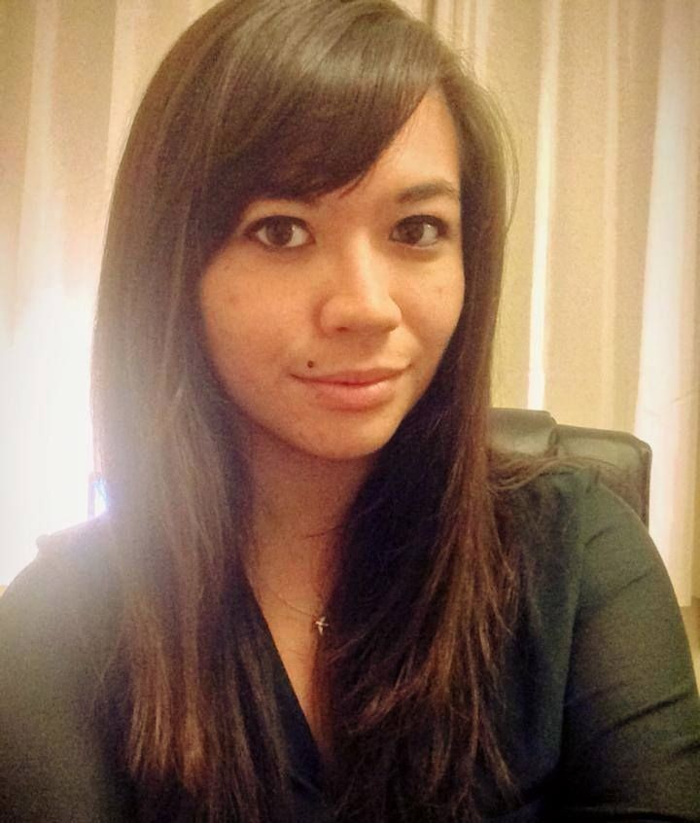

Bianca Ng
29.02.1992
65 route de Lavaur, 31850 Montrabé
06 20 89 04 62, ngcbianca@gmail.com

Personal Profile
After graduating from the University of East Anglia in Norwich, England with First Class Honours in Translation and Interpreting with French and Spanish (BA), I moved to Toulouse, France where I recently completed a Master’s degree in the same discipline as part of the European Master’s in Translation programme. As a passionate linguist, I make the most of my acquired knowledge and skills through a shared involvement in both English teaching (having obtained my TEFL qualification in 2015) and translating.

Professional Experience

Freelance translator

(June 2018 - present)

- Translation intern, Coup de Puce Expansion, Toulouse
(March - June 2018)
Internship as part of the final semester of my Masters degree - translation, proofreading, term base management.

English teacher, Inlingua, Toulouse

(April 2016 - September 2017)
Providing one-to-one and group English lessons to adult professionals and job-seekers.

Tutor, IPSA (Institut polytechnique des sciences avancées), Toulouse

(September 2015 - August 2016)
Running group conversation sessions, games and activities as part of the ‘Piscine d’anglais’ programme at an engineering faculty in Toulouse.

Volunteer Translator, SKIP (Supporting Kids In Peru)

(May 2015 - present)
Translating documents for an NGO based in Peru.

French-speaking assistant, Tin Can Island (TV productions), Norwich

(May - June 2015 - Paid work experience)
Helping with arrangements for TV programme ‘Wild France’ with Ray Mears: confirming times of filming with contributors, booking hotels and restaurants, translating research, helping to set up filming locations and travel requirements.

Healthcare Advisor, Boots the Chemist, Cambridge

(2010 - 2011)
Providing over-the-counter pharmaceutical products, helping customers on the shop floor within the healthcare department, operating the till and taking special orders, stock replenishment.

Bar staff, Aki-Teri, Cambridge

(2008 - 2009)
Preparing beverages, operating the till, replenishing the bar, preparing certain desserts, general bar maintenance and cleaning.

Administrative Assistant, Eurocentres English Language School, Cambridge

(2 weeks of work experience, 2008)
General administrative and receptionist duties - answering phones, e-mailing, spreadsheets, taking payments for various fees, handling post and correspondence.

Education

Masters (European Masters in Translation) - Université de Toulouse 2 - Jean Jaurès

(2016 - 2018)

Language A: French Language B: English Language C: Spanish

Traduction, Interprétation et Médiation Linguistique.
Research thesis entitled: Comedians don’t tell jokes : Traduire le stand-up.
An exploration of the translation of stand-up comedy from French to English and vice versa.

- Bachelor of Arts - University of East Anglia, Norwich
(2011 - 2015)

Translation and Interpreting with French and Spanish - First Class Honours. Distinction for Oral Achievement in Final Year French and Spanish Language.

- A Level - Hills Road Sixth Form College, Cambridge
(2008 - 2010)

French: A Spanish: A
English Language: B Sociology: B

- GCSE - St. Mary’s School, Cambridge
(2006 - 2008)

French: A* Spanish: A* Latin: A
English Literature: B English Language: A Science: B Additional Science: A Mathematics: B Religious Studies: B Art: C

Skills
- TEFL (Teaching English as a Foreign Language) qualified
- Full, clean drivers’ license and own transport.
- High proficiency in French and Spanish.
- ECDL (European Computer Driving Licence): ICT Qualification.
- ABRSM qualifications in voice, clarinet and piano varying up to Grade 6 of 8.

References available on request.

