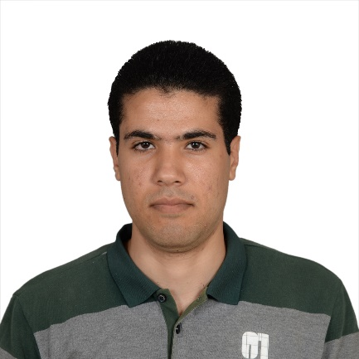
C.V

- Personal Information

Date of Birth | Age | Place of Birth | Nationality | Name
14/11/1990 | 26 | Al Sharkia Governorate | Egyptian | Khaled Abdel Nasser Mohamed Ali
Egypt – Al Sharqiya - Fakous |  |  | Address | 055-3810465 | Home Number
soltan.khaled@yahoo.com |  |  | E-mail | +20-1285496568 | Mobile number
Ministry of Education |  |  | Employer | English Teacher | Job Title
Single |  |  | Marital Status | Muslim | Religion

- Academic Qualifications and Certificates

# | Qualifications | Date | Grade | Institution | Specialty
1 | B.A English Department | 5/2011 | 64.6% | Faculty of Arts – Zagazig University | English Department
2 | General Diploma in Education | 6/2013 | 71.32% | Faculty of Education – Suez Canal University | English Department
3 | Special Diploma in Education | 6/2014 | 83.33% | Faculty of Education – Suez Canal University

- Courses

# | Course | Degree | Date | Institution
1 | ICDL | V.5 | 19/8/2014 | Act Academy – Ismailia
2 | TOEFL | 610/675 | 24/9/2014 | Languages Center – Suez Canal University

- Experience

Job | English Teacher | Place | Al Maghara Elementary School | Time | 6/2012 - Present
tasks | English Teacher
Text translation - Movies subtitling and translation 2013 - present

