curriculum vitae |  |  | 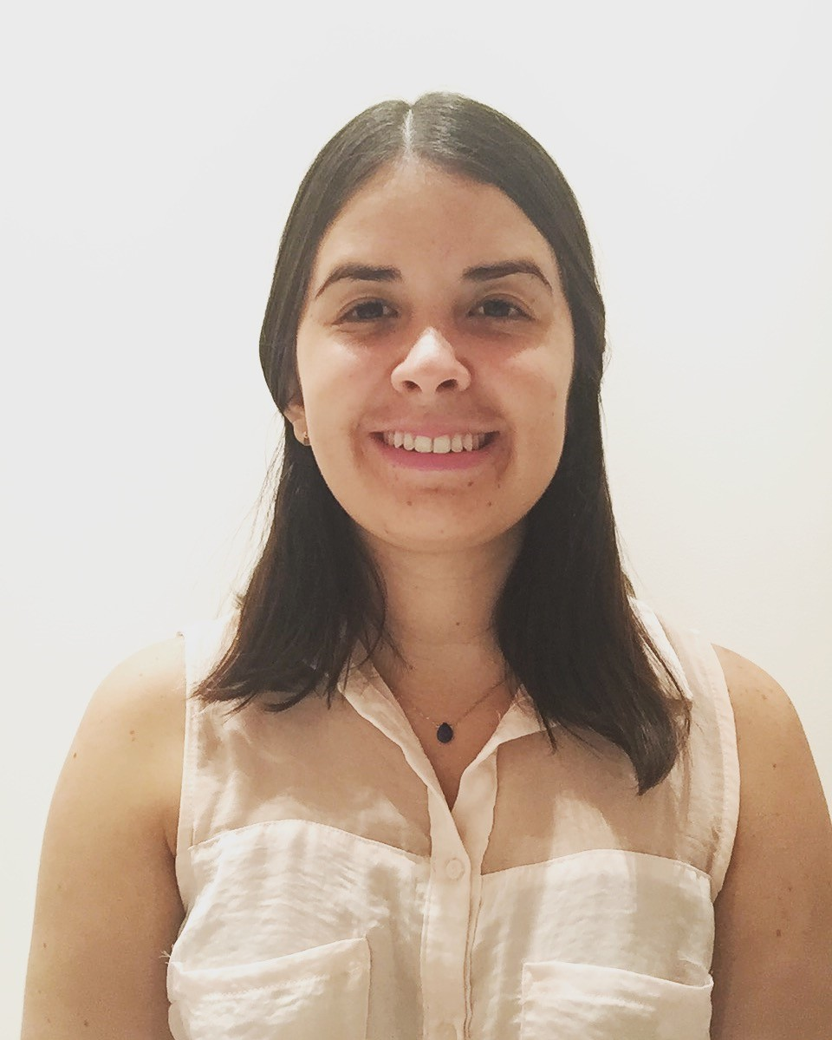
Eleonora Holst Pérez
aPersonal information | - I.D. number  - Date and place of birth  - marital status  - Address  - Cellphone number  - E-mail Address | 0918032715  Guayaquil, January 22nd, 1991  Single  Cdla. Puerto Azul, Mz.#308 Sol.#4  593-9-99138225  eleonoraholst@hotmail.com
bEducational  Background | - June 2009 - present  - January 2009 | Bachelor in Crative Writing with a minor in Professional English Skills and Communication Studies at Universidad de Especialidades Espíritu Santo (UEES)  Graduated at Salinas Jefferson High School
CProfessional Experience | - July 2015  - November 2013 - present | Writer and translator of an article from Spanish into English for Destinos maganize from Santa Elena, Ecuador.  Translator at Children International Foundation, Guayaquil agency.
DComplementary Training | - 2012 | Legal translation workshop at Universidad de Especialidades Espíritu Santo (UEES)
eFurther Information, Languages | - Advanced English Proficiency (90%)
F Personal References | - Dr. Hernán Pérez Loose “Estudio Corenel & Pérez”  - Silvia Rivera San Lucas | Lawyer  Phone numbers.: 04-519900 - 0994474000  Social and Administrative Director at VIHDA Foundation, Guayaquil  Phone number: 04-2311451

