CURRICULUM 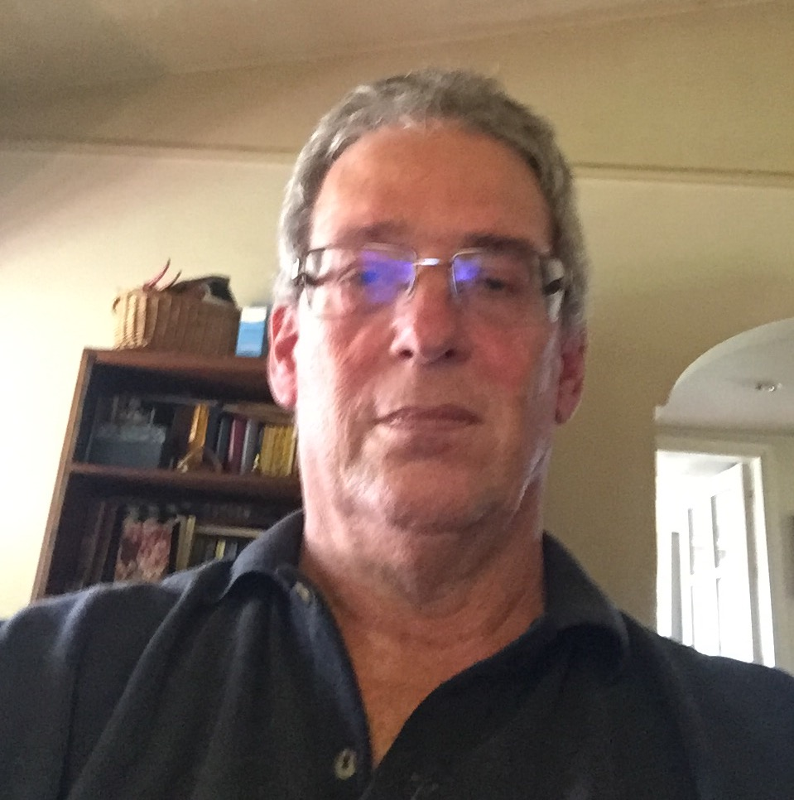

NAME: DANIEL FEUERSTEIN
DATE OF BIRTH: FEBRUARY 27, 1957 IN MONTEVIDEO/URUGUAY
CITIZENSHIP: GERMAN AND URUGUAYAN
MARITAL STATUS: MARRIED – TWO CHILDREN (SON 31 – DAUGHTER 27)
ADDRESS: GRAL NARIÑO 2324 – 11500 MONTEVIDEO – URUGUAY
TELEPHONE: +5982-600-2624 HOME
MOBILES: +5989-4-431096 / +5989-9-431096
EMAIL: DANIEL@PROMARKETING.COM.UY DAFEUER@NETGATE.COM.UY
DANIELFEUERSTEIN57@GMAIL.COM
STUDIES: ELEMENTARY, HIGH SCHOOL AND BUSINESS SCHOOL AT “DEUTSCHE SCHULE” IN MONTEVIDEO (GERMAN SCHOOL)
BACHELLORS DEGREE IN BUSINESS AND ADMINISTRATION.
LANGUAGES: SPANISH (NATIVE), ENGLISH (NEAR NATIVE), GERMAN (ADVANCED).
WORK EXPERIENCE: SINCE DECEMBER 2016 FREELANCER INTERPRETER AND TRANSLATOR ENGLISH-SPANISH, SPANISH-ENGLISH, GERMAN-ENGLISH, GERMAN-SPANISH.
SINCE 2013 OWNER OF ORKI URUGUAY TONS LTDA. IMPORTER OF PET ACCESSORIES (SOLVIT PRODUCTS USA) AND SERVICES PROVIDER AS FREELANCER AND CONSULTANT.
FROM 2014 TO JANUARY 2016 LATIN AMERICA (EXCEPT BRAZIL) SENIOR BUSINESS CONSULTANT FOR THE MARKETING STORE.
FROM 2001 TO 2013 PRESIDENT OF DT ENTERTAINMENT WHICH CREATED AND BOOKED CHILDREN LIVE THEATER SHOWS FOR LATIN AMERICA. FROM THE SCRIPT UP, WE WROTE, ADAPT AND TRANSLATE SCRIPTS, DESIGNED SETS, MANUFACTURED OUR OWN COSTUMES AND WARDROBES, HIRED AND TRAINED CAST AND CREWS, AND GOT THEM APPROVED BY EACH LICENSOR (SOME EXAMPLES: BEN 10 LIVE SHOW, BACKYARDIGANS LIVE, STRAWBERRY SHORTCAKE LIVE, BARNEY AND FRIENDS LIVE, DOKI LIVE, HELLO KITTY LIVE, STAR WARS MEET & GREETS, SPIDERMAN AND IRON MAN M&G, ETC.)
1991-2013 CEO AND PARTNER OF EXIM LICENSING GROUP – URUGUAY –LICENSING AGENTS FOR (AMONG OTHERS): WARNER BROS., SANRIO, HIT ENTERTAINMENT, LUCAS FILMS, DISCOVERY COMMUNICATIONS, AMERICAN GREETINGS, SABAN, ETC. FOR LICENSING AND PROMOTIONS.
1998-1999 CONSULTANT FOR THE MARKETING STORE WORLDWIDE – CHICAGO, ILLINOIS, TO ESTABLISH A MANUFACTURING OPERATION FOR MCDONALD´S HAPPY MEAL PROGRAMMS (SELECTION OF PROPER PARTNERS IN SOUTH AMERICA TO CREATE, MANUFACTURE, INSPECT PREMIUM ITEMS FOR THE REGION), CONSULTANCY ENDED AHEAD OF SCHEDULE WITH THE CREATION OF A SUBSIDIARY OF TMSW IN BRAZIL.
1989 UNTIL 1991 VICE PRESIDENT AT RIEKER SHOE CORPORATION USA, BASED IN NORTHERN CALIFORNIA, USA WITH ALL RESPONSIBILITIES OF A COO AND CEO.
1985 UNTIL 1988 SALES MANAGER WEST COAST OF SALAMANDER FOOTWEAR INC. WITH BASE IN SAN FRANCISCO, CALIFORNIA, USA.
1981 UNTIL 1985 SALAMANDER AG, KORNWESTHEIM, GERMANY, AREA MANAGER EXPORT DIVISION RESPONSIBLE FOR THE US, BRITISH, IRISH, CANADIAN, SPANISH AND SOUTH AMERICAN MARKETS.
1979 UNTIL 1981 MANAGER AT SALAMANDER FASHIONS S.A. MONTEVIDEO, A SUBSIDIARY OF SALAMANDER AG, GERMANY.

