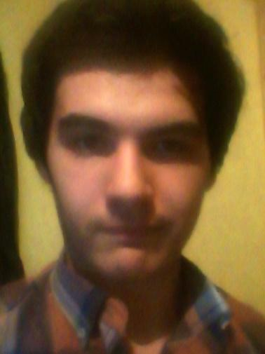
NAME: BERKAY
SURNAME: KOÇ
OCCUPATION: STUDENT
LANGUAGE PAIR: ENGLISH-TURKISH
SERVICES OFFERED: LOCALIZATION, TRANSLATION, PROOFREADING, SUBTITLING
CONTACT INFORMATION
PHONE: +90-537-836-09-67
E-MAIL: uppercut733@hotmail.com

EDUCATION
-Attended to Vahide Aktuğ Elemantary School between 2005-2013.
-Attended to Süleyman Çelebi Anatolian High School between 2013-2017.
-Attending to Uludağ University - ELT branch since 2017.

PAST ACTIONS
-Started to translate as a voluntary anime translator in 2012.
-Joined a Turkish game localization team called Türkçe-Oyun in 2013. Former member, due to disbandment.
-Started Little Busters! Turkish Localization Project in 2013.
-Released Little Busters!’ Turkish trial version in 2014.
-Started FUEL Localization Project and released a Turkish patch in 2015.
-Became one of the co-founders of BakaYume Translation Team.

PROFESSIONAL
GAME LOCALIZATION [EN-TR]:
-Bioshock Infinite (Türkçe-Oyun’s project)
-Bioshock Infinite – Burial At Sea Season 1 (Türkçe-Oyun’s project)
-Dragon Age 2 (Türkçe-Oyun’s project. Project is abandoned after the disbandment of Türkçe-Oyun.)
-FUEL (My personal project dedicated to Türkçe-Oyun)
-Grand Theft Auto IV: The Lost and The Damned (Türkçe-Oyun’s project)
-Little Busters! (My personal project. Project is still ongoing.)
-planetarian ~the reverie of a little planet~ (BakaYume’s project. Patch v1.0 is released)
-Ballistic Overkill (BakaYume’s official project. Localization added to the Steam version and is updated regularly.)
-Clannad Side Stories (BakaYume’s project. Patch v1.1 is released)
-Doki Doki Literature Club! (BakaYume’s project. Patch v1.1 is released)
-G-Senjou no Maou (BakaYume’s project. Project is ongoing but isn’t made public.)
-Kara no Shoujo (BakaYume’s project. Project is ongoing but isn’t made public.)
-Narcissu 1&2 (BakaYume’s project. Project is ongoing but isn’t made public.)
-Phenomeno (BakaYume’s project. Project is ongoing but isn’t made public.)
-Saya no Uta (BakaYume’s project. Project is ongoing but isn’t made public.)

SUBTITLING [EN-TR]:
-Charlotte (4/13 episodes, project abandoned.)
-Gen’ei wa Kakeru Taiyou (10/13 episodes, project abandoned.)
-Little Busters! EX
-Phi Brain - Kami no Puzzle (Season 3, translated the last 11 episodes that has been left out.)
-Planetarian ~Chiisana Hoshi no Yume~
-Gochuumon wa Usagi Desu ka (a few episodes)
-MIT’s Introduction to Computer Science and Programming in Python Course (Lecture 1 is translated, translation of the remaining episodes are ongoing.)

