ANUSCH YAEL RICAUD SICOLO

CERTIFIED TRANSLATOR (English<>Spanish)

TECHNICAL AND SCIENTIFIC TRANSLATOR (English<>Spanish)

PERSONAL INFORMATION
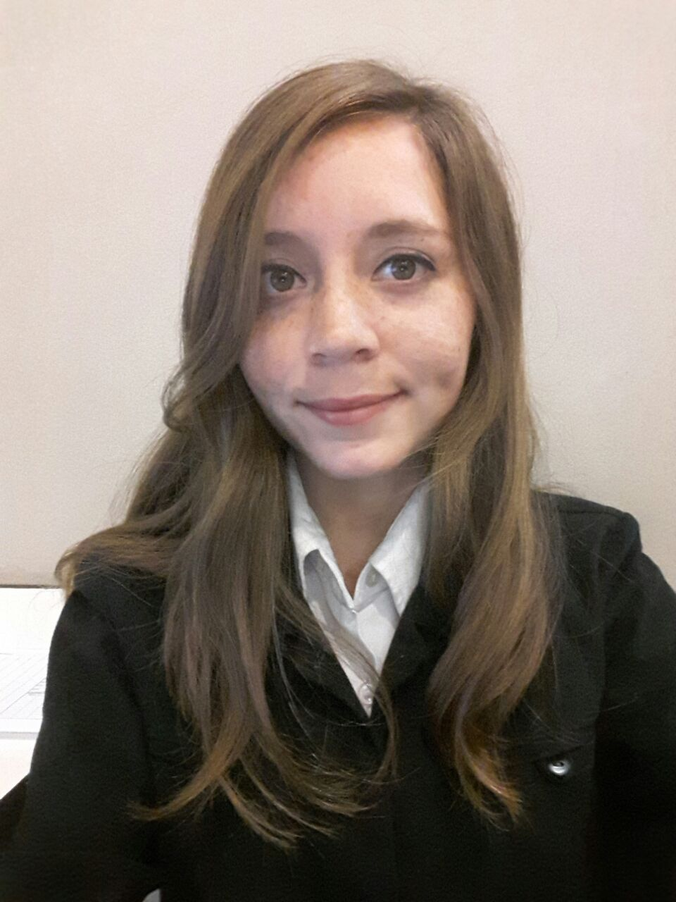
Name: Anusch Yael Ricaud Sicolo
Nationality: Argentinean. Italian citizenship.
Mobile: +5492235917321
Email: anusch.ricaud@gmail.com
Skype ID: anusch.ricaud
ProZ: http://www.proz.com/translator/1826092
LinkedIn: https://ar.linkedin.com/in/anuschricaud
About me: https://about.me/Anusch.Ricaud

WORK EXPERIENCE

May 2017 - Today | Front Desk Receptionist at Sheraton Mar del Plata Hotel.
2015 – Today | Freelance translator of technical and scientific texts.
March 2017 – Today | Assistant professor. Subject: Economics Translation II. CAECE University, Mar del Plata.
October 2015 – March 2017 | Guest Services Operator, Internship at Sheraton Mar del Plata Hotel.
2011 – 2015 | Professional training practices organized by the University.

AREAS OF SPECIALIZATION
Translation of technical, scientific, legal and economic texts.

EDUCATION
2012 – 2017 Certified Translator (English<>Spanish) at CAECE University, Mar del Plata, Buenos Aires, Argentina.
2012 – 2015 Technical and Scientific Translator (English<>Spanish) at CAECE University, Mar del Plata, Buenos Aires, Argentina.
Average grade: 7,13.
Web Access to CAECE University: http://www.ucaecemdp.edu.ar/

2006 – 2011 High School Title: Economics and Organizations Management

LANGUAGE PROFILE
Native Language: Spanish
Foreign language: English (formally acquired)
Certificates: Preliminary English Test (PET) - Grade: Pass with Merit / First Certificate in English (FCE) – Grade: B

SOFTWARE

Microsoft Office: Word, Excel, PowerPoint
SDL Trados
Memsource
MemoQ: Level one certified.

COURSES AND SEMINARS TAKEN
- Jornada de Iniciación Laboral para el Traductor (Conference for translators on how to start working) – CAECE University, Mar del Plata, 2013.
- 2013 freelance translator virtual conference –ProZ.com
- Translator Boot Camp - What is in your tool box? - ProZ.com
- CAT Tool & Software Day - ProZ.com
- 2013 Recruitment virtual event - ProZ.com
- ProZ.com Networking Marathon - ProZ.com
- Curso Plan de Negocios (Course on Business Plan), CAECE University, 2013
- Curso Inglés para Traducciones Jurídicas (Course on English for Legal Translations) – CAECE University, Mar del Plata, 2013
- CAT Tool & Software Day
- ProZ.com's 2014 virtual conference for International Translation Day
- Jornadas de Introducción a las Herramientas Electrónicas del Traductor del Siglo XXI (Introduction to translators software tools of the 21st century), Miriam Seghiri, CAECE University, Mar del Plata, 2015.
- Disertación sobre Aspectos Fundamentales para la Traducción de Subtítulos (Fundamental Aspects of Subtitles Translation), Xosé Castro Roig, CAECE University, Mar del Plata, 2015.
- CAT Tool & Software day - September 29, 2015
- ProZ.com 2015 virtual conference for International Translation Day - September 30th, 2015
- Jornadas Argentinas de Tecnología, Innovación y Creatividad (Jatic), CAECE University, Mar del Plata, 2015.
- Primera Jornada para Traductores Públicos (First Seminar for Certified Translators), Organized by the Translators and Interpreters Professional Association of Bahía Blanca, at CAECE University, Mar del Plata, 2015.
- Seminario de ProZ.com para traductores noveles y estudiantes de traducción - Séptima edición (ProZ seminar for novice translators and translation students)
- Translation for environmental organizations (training session in Proz.com)
- Introductory E-Course on Climate Change, UN CC:LEARN, 2016.
- VI Congreso Latinoamericano de Traducción e Interpretación (VI Latin American Conference on Translation and Interpreting), 2016.

