ANUSCH YAEL RICAUD SICOLO

TECHNICAL AND SCIENTIFIC TRANSLATOR (English<>Spanish)

PERSONAL INFORMATION
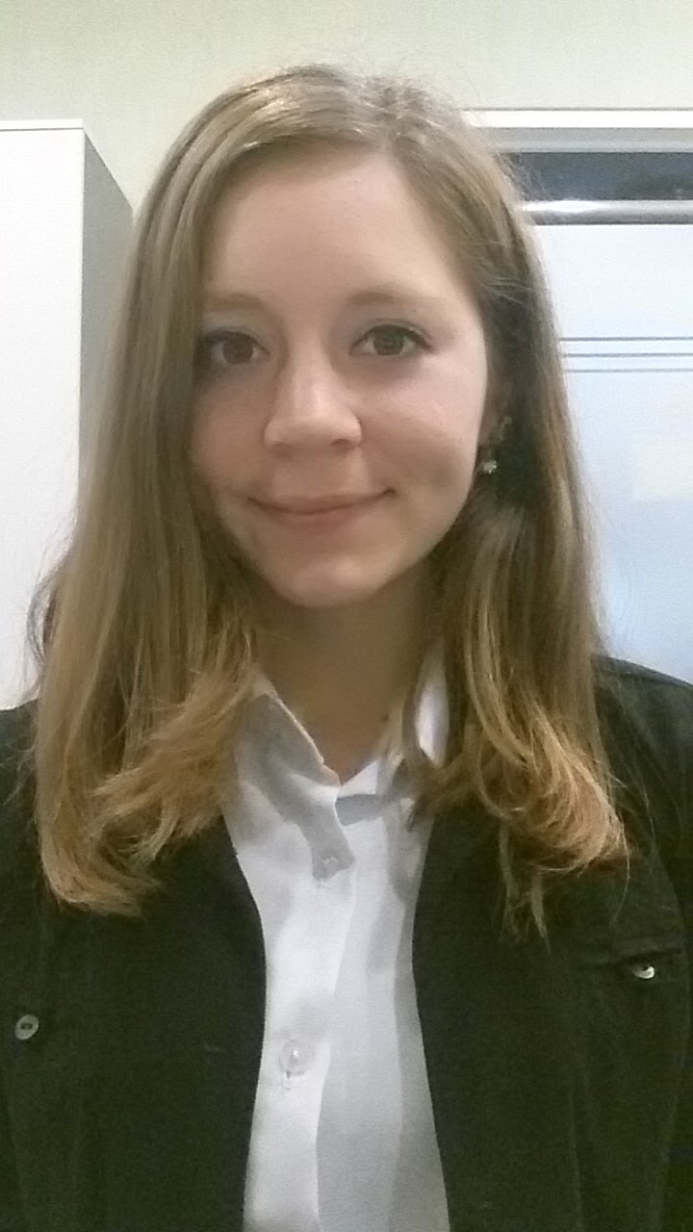
Name: Anusch Yael Ricaud Sicolo
Nationality: Argentinean. Italian citizenship.
Mobile: +5492235917321
Email: anusch.ricaud@gmail.com
Skype ID: anusch.ricaud
ProZ: http://www.proz.com/translator/1826092
LinkedIn: https://ar.linkedin.com/in/anuschricaud
About me: https://about.me/Anusch.Ricaud

WORK EXPERIENCE

October 2015 – Today

2014 – 2015

Guest Services Operator, Internship at Sheraton Mar del Plata Hotel.

Freelance translator of technical and scientific texts.

AREAS OF SPECIALIZATION
Translation of technical, scientific, legal and economic texts.

EDUCATION
2012 – Today Certified Sworn Translation student (English<>Spanish) at CAECE University, Mar del Plata, Buenos Aires, Argentina (4 finales left to obtain degree).
2012 – 2015 Technical and Scientific Translator (English<>Spanish) at CAECE University, Mar del Plata, Buenos Aires, Argentina.
Average grade: 7.28
Web Access to CAECE University: http://www.ucaecemdp.edu.ar/

2006 – 2011 High School Title: Economics and Organizations Management

LANGUAGE PROFILE
Native Language: Spanish
Foreign language: English (formally acquired)
Certificates: Preliminary English Test (PET) - Grade: Pass with Merit / First Certificate in English (FCE) – Grade: B

SOFTWARE

Microsoft Office: Word, Excel, PowerPoint
SDL Trados
Memsource
MemoQ: Level one certified.

COURSES AND SEMINARS TAKEN
- Jornada de Iniciación Laboral para el Traductor (Conference for translators on how to start working) – CAECE University, Mar del Plata, 2013.
- 2013 freelance translator virtual conference –ProZ.com
- Translator Boot Camp - What is in your tool box? - ProZ.com
- CAT Tool & Software Day - ProZ.com
- 2013 Recruitment virtual event - ProZ.com
- ProZ.com Networking Marathon - ProZ.com
- Curso Plan de Negocios (Course on Business Plan), CAECE University, 2013
- Curso Inglés para Traducciones Jurídicas (Course on English for Legal Translations) – CAECE University, Mar del Plata, 2013
- CAT Tool & Software Day
- ProZ.com's 2014 virtual conference for International Translation Day
- Jornadas de Introducción a las Herramientas Electrónicas del Traductor del Siglo XXI (Introduction to translators software tools of the 21st century), Miriam Seghiri, CAECE University, Mar del Plata, 2015.
- Disertación sobre Aspectos Fundamentales para la Traducción de Subtítulos (Fundamental Aspects of Subtitles Translation), Xosé Castro Roig, CAECE University, Mar del Plata, 2015.
- CAT Tool & Software day - September 29, 2015
- ProZ.com 2015 virtual conference for International Translation Day - September 30th, 2015
- Jornadas Argentinas de Tecnología, Innovación y Creatividad (Jatic), CAECE University, Mar del Plata, 2015.
- Primera Jornada para Traductores Públicos (First Seminar for Certified Translators), Organized by the Translators and Interpreters Professional Association of Bahía Blanca, at CAECE University, Mar del Plata, 2015.
- Seminario de ProZ.com para traductores noveles y estudiantes de traducción - Séptima edición (ProZ seminar for novice translators and translation students)
- Translation for environmental organizations (training session in Proz.com)
- Introductory E-Course on Climate Change, UN CC:LEARN, 2016.
- VI Congreso Latinoamericano de Traducción e Interpretación (VI Latin American Conference on Translation and Interpreting), 2016.

