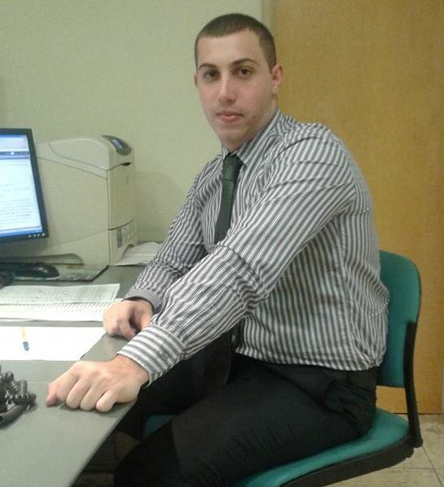

Date of birth: 16/09/1988;
Place of birth: Villa Flandria (Argentina);
ID number: 33.904.003;
Civil status: Single, no children;
Citizenship: Argentinean and Italian;
Address: Tandil 5648 PB 4 – 1440 Buenos Aires.

Professional profile

National Sworn Translator -Italian language- graduated from the Law School of the University of Buenos Aires in November 2012.

Work experience

Senior Associate
Accenture Argentina. Business Process Outsourcing. Customer Relationship Management. Requisitions to pay – Italy. From July 2014.

Front Desk operator
General Consulate of Italy in Buenos Aires. Office: "Poli-functional 1" (Civil registry, Registry of Persons, Elections, Passports): Military service - Front Desk. Tasks performed: Public reception, changes of address, deaths, military regularization, and general information. From May 2013 to May 2014. Certain time contract through the GI Group Temporary Staffing Agency.

Freelance Translator
Different jobs for the argentine and foreign market.

Italian language teacher
Dante Alighieri Association - Luján city. Teacher of first, second and third year of Italian language and civilization. Conversation, grammar and culture (art, history and literature) lessons. From March 2009 to December 2012.

Academic background
National Sworn Translator
Law School. Buenos Aires University. November 2012. Registered in the Sworn Translators' College of the City of Buenos Aires.
Law
Law School. Buenos Aires University. 15 subjects

Electromechanical Technician
San Luis Gonzaga Institute - Algodonera Flandria Technical School. Best course average. Special mention of the Rotary Club. Year: 2006. Average: 8.34.

High School degree: Goods and services
San Luis Gonzaga Institute - Algodonera Flandria Technical School. Best course average. Special mention of the Rotary Club. Year: 2006. Average: 9.45.

Courses and other activities

Languages:
Spanish: Native speaker.
Italian: Optimum level. Extensive knowledge of legal terminology and comparative law.
English: Level: Very good.
Computing: Excellent knowledge of office package. Database creation. CAT Tools. SDL Trados. Autocad. Siebel System.

Courses:
Italian Language and Civilization. Dante Alighieri. Luján. Duration: three years. Rating: Excellent. Ended in December 2005.

Italian Culture, Art, History and Literature. Dante Alighieri. Luján. Duration: three years. Rating: Excellent. Ended in December 2008.

V International UNESCO Model in Argentina. José Hernández Institute of Villa Ballester. Year: 2006.

Italian Language and Culture intensive course. Udine University. July 2012. Scholar of the university, the Friuli-Venezia Giulia Region and the Friuli nel Mondo Organization. Level: Advanced. Rating: "optimum" A.

Conferences: "The Penal Mediation in Italy." Organised by Dr. Elbert's Chair and the Argentinean Attorney General's Office and taught by Dr. Ceretti of the University of Milan. Law School. Buenos Aires University. September 2010.
III International Forum of Specialized Translation. Sworn Translators' Association of the City of Buenos Aires. Buenos Aires. July 2011.
"The Italian civil process I". Organized by the Sworn Translators' Association of the City of Buenos Aires. April 2013.
"The Italian civil process II". Organized by the Sworn Translators' Association of the City of Buenos Aires. May 2013.
"The Italian civil process III". Organized by the Sworn Translators' Association of the City of Buenos Aires. July 2013.
"The Italian civil process IV". Organized by the Sworn Translators' Association of the City of Buenos Aires. July 2013.
Lucas Sebastián TADEO
Tandil 5648 PB 4 Buenos Aires. Argentinean Republic
Mobile Phone
+54 011 15 35979806
E-mail
lucassebastiantadeo@live.com
"The Italian civil process V". Organized by the Sworn Translators' Association of the City of Buenos Aires. August 2013.
"The Italian financial report I". Organized by the Sworn Translators' Association of the City of Buenos Aires. September 2013.
"Societies in Argentina and Italy". Organized by the Sworn Translators' Association of the City of Buenos Aires. May 2014.
“Difficult sounds of Italian language”. Organized by the Sworn Translators' Association of the City of Buenos Aires. June 2014.
“Interpretation in Italian language”. Organized by the Sworn Translators' Association of the City of Buenos Aires. July 2014.

