CV
Personal details:  - Name: Yara Vidalina  - Surnames: Prieto Ortiz  - Date of birth: 14/02/1992  - Address: Carrer de Comte d’Urgell 35, 7º 4ª. Barcelona (ESPAÑA)  - ZIP code: 08011  - E-mail address: yara.prieto@yptraducciones.com  - Telephone number: +34 685 77 07 69  - Driving license: B | 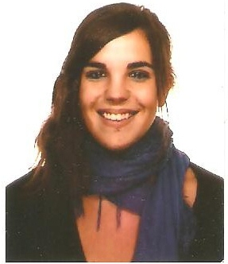  Audiovisual translator and localiser. Professional proofreader.  EN>ES  RU>ES  ES>EU  EU>ES

Studies:
- Degree in Translation and Interpreting (specialised in English and Russian) at UPV/EHU (Vitoria-Gasteiz, Spain) (2010-2014)
- Second year of the Degree in Translation and Interpreting at Moscow State University (Moscow, Russia) as an Erasmus student. (2011-2012)
- Master’s Degree in Audiovisual Translation at Universitat Autònoma de Barcelona (Barcelona, Spain) (2014-2015)
- Calamo & Cran’s online Proofreading Course of the European University of Mdrid (February-May 2016)

Languages:
- Basque and Spanish (native)
- English (C2 certified by university studies)
- Russian (B2-C1 certified by university studies)
- German (medium/high. B1.2 certificate)
- Catalonian (medium/high)

Work:
- Freelance subtitle proofreader EN>ES at Pequerrecho Subtitulación (since December 2016)
- Telemarketin phone operator at Unísono BPO S.L. (since March 2016)
- Freelance subtitler at Pequerrecho subtitulación (since December 2015)
- Bilateral interpreting EN<>ES at Jaques Dalcroze Method Course at Escola de Música Joan Llongueres.
- Subtitling for the Human Rights Film Festival of Barcelona (May 2015)
- Private language classes (since 2011)
- English teacher at Kith (Barcelona) (October 2014- January 2015)
- Translator and English teacher at Zador Language Services (January-July 2014)
- EN>ES Translator for UNIS Vienna (UNO) (November 2013)
- EN>ES Volunteer Translation for the Red Cross (November 2013)
- Simultaneous Interpreting at a medical congress at Cruces hospital (Barakaldo, Spain) (November 2013)
- English conversation teacher at the City Library of Ermua (Spain) (October-December 2013)

IT:
- Trados
- Omega T
- Déjà Vu
- Wordfast
- Office

Others:
- Audiovisual Translation Meeting (BdeBaobab) in Bilbao, Spain (April 2014)
- Spanish as a Foreign Language Teacher course. (September-November 2013)

