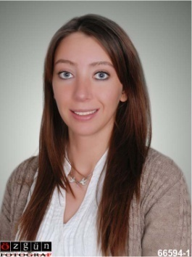
Ece Güneş
Mesa Koru Sitesi Zambak blok
No:35 Çayyolu Ankara
+905377601422
E-mail: ecegnes@gmail.com

EDUCATION

1996-2007: ODTU elementary, middle, and high school

2007- 2013: Bilkent University Translation and Interpretation (Turkish, English, and French)

2011-2012: Hacettepe University English Training Education (English)

PROFESSIONAL EXPERIENCE

February - July 2010: Red Bull Sales Representative
Worked in sales and marketing.

July – August 2010: Medart
I acted as sales and marketing director

January – July 2012: Mesa Koru İlköğretim Okulu English Teacher Internship

August 2012 – September 2012: TRT (Turkish Radio and Television Cooperation)
Foreign Relations Department (Translator)

June 2013: Havelsan
Translated defense aircraft users’ manuals.

October –November 2013: Doktorlar Kindergarten
Taught English.

November 2013: Tekdil Eğitim Kurumları
Taught English (Part Time)

SEMINARS AND COURSES TAKEN

- Bilkent University Personal Development Seminar
- Three weeks of French language training in Euro centers Paris
- FIFA World Cup (Translating)
- MUN TOBB University Conference (2008)
- Vichy (France), Cavillam, French training
- Hosted a seminar on civil responsibilities in Bilkent University (“Are you aware?”)

SOCIAL RESPONSIBILITY

- LÖSEV member
- Köroğlu Leo Club Member (2012-2013)
- Köroğlu Leo Club Secretary (2013-2014)

FOREIGN LANGUAGES

English - Fluent
French - Fluent
Spanish - Intermediate
Italian - Beginner

REFERENCES

Şirin Okyayuz Yener- 0532 366 12 88 Bilkent University Department of Translation and Interpretation

Ali Kemaloğlu – 0532 292 88 39 –Presidcent and CEO of Turmaks, NANOmaks, Asina Kitaplar Founder, TAA chairman

Yalçın Topkaya- 0533 276 91 32 - Medart Medical Co. General Manager

