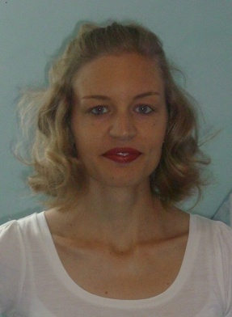
Curriculum Vitae

Personal Details _____________________________________

Name  Surname  Marital Status  Date of Birth | Edeltraud Maria Sabine  Achten  seperated  25.06.1981

Professional Experience ________________________________________________

August 2008 - December 2010 | Language Center at the University of Huánuco, Perú  - Lecturer in English

Experience ___________________________________________________________

23.09.2002 – 11.10.2002  October 2003 – February 2004  27.07.2006 – 04.10.2006 | School for special education, Sulzbach-Rosenberg, Germany  Secondary School, Mannheim, Germany  Chance e.V., Huánuco, Perú

University Education ___________________________________________________

01.10.2001 – 30.09.2004 | Teacher for special education, PH Heidelberg, Germany
01.10.2004 – 31.03.2005 | Teacher for secondary school, University of Dortmund, Germany
01.04.2005 – 30.09.2008  29.04.2008 | Roman Philology and Education, Ruhr Universität Bochum, Germany  Bachelor of Arts  Final grade: 1,2  Topic of Thesis: La presentación de la realidad étnica en el Peru moderno en la obra de Ciro Alegría y José María Arguedas  Final grade: 1,3

Education ____________________________________________________________

1987 – 1991  1991 – 2000  30.06.2000 | Primary School, Etzelwang, Germany  Secondary School, Max Reger Gymnasium, Amberg, Germany  Graduation  Final grade: 1,7

Experience abroad _____________________________________________________

August 2000 – August 2001  27.07. 2006 – 04.10.2006  16.06.2008 - 19.01.2011 | Au pair in London, Great Britain  Voluntary work at Chance e.V. in Huánuco, Perú  Lecturer at UDH in Huánuco, Perú

Participation in Council _________________________________________________

01.10.2002 – 30.09.2003 | Elected Student Member in the Council of Faculties, PH Heidelberg, Germany

Skills ________________________________________________________________

Languages

German  Spanish  English | Native speaker  Fluent in speaking and writing  Fluent in speaking and writing

Computer

Windows, Linux, Word, Excel, Acrobat Reader, Powerpoint, OpenOffice, Internet

